Table of Contents

1.0 Introduction 01

1.1 Purpose of the document 01

**1.2 Definitions and Acronyms 01**

**1.3 Project Overview 01**

**1.4 In Scope 01**

**1.5 Intended Audience 02**

**1.6 Constraints, Assumptions and Dependencies 02**

**2.0 Use Cases 02**

**2.1 Admin Home Page 03**

**2.2 Admin Register Page 04**

**2.3 Admin login Page 04**

**2.4 Books Page 05**

**2.5 Book Details page 06**

**2.6 Customer Cart Page 07**

**2.7 Customer Register Page 07**

**2.8 Customer login Page 08**

**2.9 Book details page 08**

**2.10 Add to cart page 09**

**2.11 View cart Page 10**

**2.12 Place order Page 10**

**2.13 Payments page 11**

# Introduction

## Purpose of this document

The purpose of this document is to define the use cases for Online E-Book Management System portal application.

## Definitions & Acronyms

|  |  |
| --- | --- |
| Definition / Acronym | Description |
| EBM | E-Book Management System. |

## Project Overview

Online E-book Management System is a system which maintains the information about the books present in the Application, their authors, category of books etc. This is very difficult to organize manually. Maintenance of all this information manually is a very complex task. Owing to the advancement of technology, organization of an Online E-book management becomes much simple. It has been designed according to the book details and order details functionalities that to be performed.

This platform can offer the customers to buy the books through online. The computerization of E-books helps in many instances of its maintenances. It reduces the workload of management as most of the manual work done is reduced.

## In Scope

Following are the key features that needs to be implemented for Customer and Admin:

Customer

1. Views book details
2. Add to cart
3. Removes books from the cart
4. View books in the cart
5. Places the order
6. Payment details.

Admin

1. Edit books details
2. View book details
3. View customer cart by ID

## Intended Audience

* Product Owner
* Scrum Master
* Application Architect
* Project Manager
* Test Manager
* Development Team
* Testing Team

## Constraints, Assumptions and Dependencies

**Assumptions**

None

**Dependencies**

None

**Constraints**

None

# Use Cases

There will be two types of users whom will be using this application:

1. Admin
2. Customer

Admin – Responsible for managing the book items available in Online E-Book Management System portal.

Customer – Find Books available in Online E-Book Management System portal and adds them to the cart. The customer also has the option to remove items which were already added to the cart.

Find below the list of use case diagram that represents the list of Use Cases that needs to be incorporated.

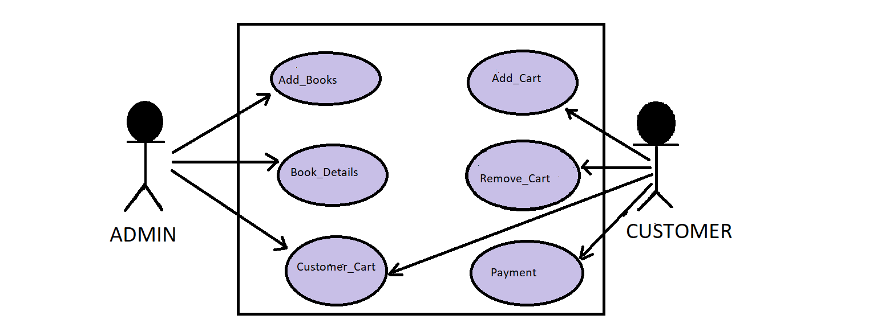

## 2.1 Admin HomePage

|  |  |
| --- | --- |
| Use Case ID | EBM1 |
| Use Case Name | HomePage(ADMIN) |
| Actor(s) | Admin |
| Description | Admin has the previleage to view the home page of the Application |
| Pre-condition | Admin should have privilege to home page application and should access the url of the application Online E-Book Management System |
| Post-Condition | Admin can register in the application |
| Basic Path | 1. Admin opens the browser and browses the application url to open the portal Online E-Book Management System portal. |

In this Page Admin can view home page of the application Online E-Book Management System portal.

## 2.2 Admin Register Page

|  |  |
| --- | --- |
| Use Case ID | EBM2 |
| Use Case Name | Register Page of Admin |
| Actor(s) | Admin |
| Description | In this page Admin can register with his valid details. |
| Pre-condition | In this case Admin can view the Home page of this application  Online E-Book Management System. |
| Post-Condition | After Registration Admin can login through his valid details. |
| Basic Path | 1. After Accessing the url of this application Admin can access the Register page of the Application. 2. In Home page admin can access the url of the register page by clicking on it. 3. After accesing the url Admin can enter the respective details and Register the details. 4. Details provided in Register page:   a)Admin Id  b)First Name  c)Last Name  d)Email Address  e)Password  f)Mobile Number |

## Admin Login Page

Admin uses this option to change details about a menu item.

|  |  |
| --- | --- |
| Use Case ID | EBM3 |
| Use Case Name | Admin Login Page |
| Actor(s) | Admin |
| Description | Admin can enter the application by using his valid login credentials in the login page. |
| Pre-condition | Admin should have previlage to register page by entering his details. |
| Post-Condition | After successful login in the application Admin can add the books to the application by accessing BOOKS url in the application. |
| Basic Path | 1. Admin after successful registration of his details can access the login page. 2. In the login page admin should enter login details like:   a)Email Address  b)Password  3. After entering the valid details it leads to successful login.  Otherwise, Enter the valid details to login. |
|  |  |

## 2.4 Books Page

Admin can add the books to application Online E-Book Management System portal.

|  |  |
| --- | --- |
| Use Case ID | EBM4 |
| Use Case Name | Books page |
| Actor(s) | Admin |
| Description | Admin adds the books to application Online E-Book Management System portal by accessing the url “BOOKS”. |
| Pre-condition | Admin should have previleage to login. |
| Post-Condition | Admin can view all the book details after adding them successfully. |
| Basic Path | 1. After successful login in the application admin can access the url “BOOKS” to add the books to portal. 2. Book details are added to the portal like:   a)Book_Id  b)Book_Name  c)Book_Author  d)Year_of_Publishing  e)Availability_of_books  f)Quantity_of_books  g)Book_Price  h)Books Category  3. The above details of the books are added to the application in the BOOKS page.  4. The Books are divided into different Categories like:  a)Technology  b)Comics  c)Historical  d)Novels  5. After Adding the books to the application Admin can also Edit ,Update, Delete the records of the books. |

## 2.5 Book_Details Page

Admin can view all the all books added to the application.

|  |  |
| --- | --- |
| Use Case ID | EBM5 |
| Use Case Name | Book_Details page |
| Actor(s) | Admin |
| Description | Admin can view all the books. |
| Pre-condition | Admin should have the privelage to add the books to the application. |
| Post-Condition | Admin Can access the cart details from the customer cart. |
| Basic Path | 1. After adding the books successfully to the portal or application admin can view the book details. 2. Book details involves like   a)book_id  b)book_name  c)book_author  d)year_of_publishing  e)availability_of_books  f)Quantity_of_books  g)book_price and H) Book Category  3. Books are also categorized, Based on customer interest  Customer can buy a wide variety of books in Online  E-Book management System application portal. |
|  |  |

## 2.6 Customer_Cart page

Admin can view the cart details of the customer.

|  |  |
| --- | --- |
| Use Case ID | EBM6 |
| Use Case Name | Customer_Cart Page |
| Actor(s) | Admin |
| Description | Admin should have privelage to view the cart details of the customer. |
| Pre-condition | Admin should have priveleage to book_details page |
| Post-Condition | Admin can logout from the application and returns to the home page of this application. |
| Basic Path | 1. Admin can view the customer cart details. |

## 2.7 Customer Register Page

Customer can enter the details for the registration.

|  |  |
| --- | --- |
| Use Case ID | EBM8 |
| Use Case Name | Register Page of Customer |
| Actor(s) | Customer |
| Description | In this page Customer can register with his valid details. |
| Pre-condition | In this case Customer can view the Home page of this application Online E-Book Management System. |
| Post-Condition | After Registration Customer can login through his valid details. |
| Basic Path | 1. After Accessing the url of this application Customer can access the Register page of the Application. 2. In Home page customer can access the url of the register page by clicking on it. 3. After accesing the url customer can enter the respective details and Register the details. 4. Details provided in Register page:   a)Customer Id  b)First Name  c)Last Name  d)Email Address  e)Password  f)Confirm Password  g)Mobile Number |

## 2.8 Customer Login Page

Customer uses this option to change details about a menu item.

|  |  |
| --- | --- |
| Use Case ID | EBM9 |
| Use Case Name | Customer Login Page |
| Actor(s) | Customer |
| Description | Customer can enter the application by using his valid login credentials in the login page. |
| Pre-condition | Customer should have previlage to register page by entering his details. |
| Post-Condition | After successful login in the application Customer view the books in the next page of this application. |
| Basic Path | 1. Admin after successful registration of his details can access the login page. 2. In the login page admin should enter login details like:   a)Email Address  b)Password  3. After entering the valid details it leads to successful login.  Otherwise, Enter the valid details to login. |
|  |  |

## 2.9 Book_Details Page

Customer can view all the all books added to the application.

|  |  |
| --- | --- |
| Use Case ID | EBM10 |
| Use Case Name | Book_Details page |
| Actor(s) | Customer |
| Description | Customer can view all the books. |
| Pre-condition | Customer should have the privelage to log into the application. |
| Post-Condition | Customer Can add the books to cart.. |
| Basic Path | 1. After login into application customer can view the book details.   2. Book details involves like  a)book_id  b)book_name  c)book_author  d)book category  e)year_of_publishing  f)availability_of_books  g)Quantity_of_books  h)book_price.  3. Books are also categorized, Based on customer interest  Customer can buy a wide variety of books in Online  E-Book management System application portal.  4. Books are categorized as different categories they are:  a)Technology  b)Comics  c)History and Novel |
|  |  |

## 2.10 Add_to_Cart

In this Page Customer can add the books to the cart in application Online E-Book Management System portal.

|  |  |
| --- | --- |
| Use Case ID | EBM11 |
| Use Case Name | Add_to_cart |
| Actor(s) | Customer |
| Description | Customer has the previleage to add books to the cart. |
| Pre-condition | Customer should have privilege to view the book_details present in the application. |
| Post-Condition | Customer has previleage to view the cart |
| Basic Path | 1.Customer after viewing of book_details present in the application then customer adds the books to the cart.  2. Customer can either add books to cart. |
| Alternative Path | 1.Customer can also Remove the books from the cart. |

## 2.11 View_Cart

In this Page Customer can view the books which are added to the cart.

|  |  |
| --- | --- |
| Use Case ID | EBM12 |
| Use Case Name | View_Cart |
| Actor(s) | Customer |
| Description | Customer has the previleage to view the books which are added to the cart. |
| Pre-condition | Customer has privilege to add the books to the cart. |
| Post-Condition | Customer has previleage to place the order. |
| Basic Path | 1.Customer can view the books which are added to the cart.  2. Customer can place the order. |

## 2.12 Place_Order

In this Page Customer can place the order in the application(Online E-Book management System) portal.

|  |  |
| --- | --- |
| Use Case ID | EBM13 |
| Use Case Name | Place_Order |
| Actor(s) | Customer |
| Description | Customer has the previleage to place the order. |
| Pre-condition | Customer has the previleage to view the cart. |
| Post-Condition | Customer has to give payment details in payment page. |
| Basic Path | 1.Customer can place the order by confirming the book details and price details and quantity of books  2. Details in the Place_Order page is:  a)Customer_id  b)Book_id  c)Quantity  d)Book_Price  e)Total_price |
| Alternative Path | 1.Customer can also Cancel the order. |

## 2.13 Payment Page

|  |  |
| --- | --- |
| Use Case ID | EBM14 |
| Use Case Name | Payment page |
| Actor(s) | Customer |
| Description | Customer has the previleage to access the payment details. |
| Pre-condition | Customer has privilege to place the order |
| Post-Condition | Order placed!!! Logs out !! returns customer home page |
| Basic Path | 1.Customer gives payment details and succesfully places order |

In this Page Customer gets the payment details of the books.

# 